Asia-China-Coin-Knife-Straight-H 4.75-R 2-300-250 BCE

The word"蔺"(Lin) was a place of Zhao Nation (403-228 BCE),Warring States Period. Now it lies in the West of Li Shi Country, Shan Xi Province. From that, we can know the exchange in the economy and culture between these nations. Obv. Lin, Place name, length 11CM/4.33Inches, width 1.3CM/0.51Inches. H 4.75

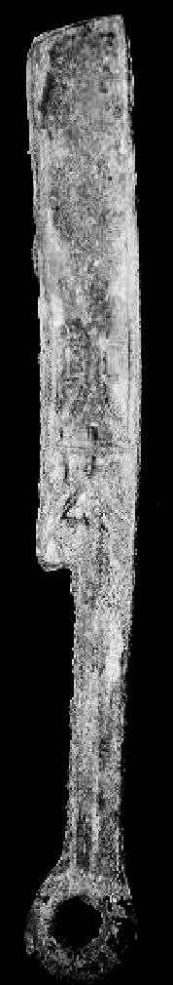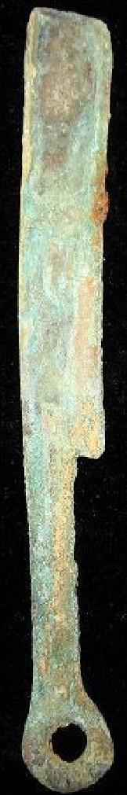

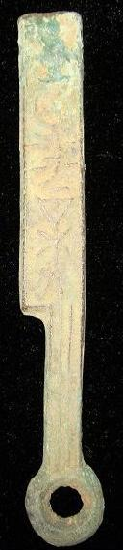 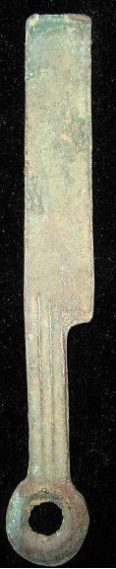

"晋阳新化"on the face. 9.4CM/3.70Inches, width 1.4CM/0.55Inches H 4.74 R 0

晋阳新化直刀."Jin Yang Xin Huo"Falchion- shape Coin.Also called"圁阳新化".The word"晋阳"(JinYang), place in the Spring and Autumn Period and later. It was made as the capital of Zhao Nation (403-228BCE) in the Warring States Period. Now it lies in the Jin Yuan Area, Tai Yuan City, ShanXi Province."新"New, Corresponding the old coin."化"also"货"which means coin. It was used in the Zhao Nation, Warring States period.

Falchion Coin,刀币,life tool.It was used in the Qi,Yan and ZhongShan Nation since early Spring and Autumn Period to late warring states period.The Falchion coin is came from a fishing tool,falchion.

This collection is a very rare Bronze Falchion-shape Coin.

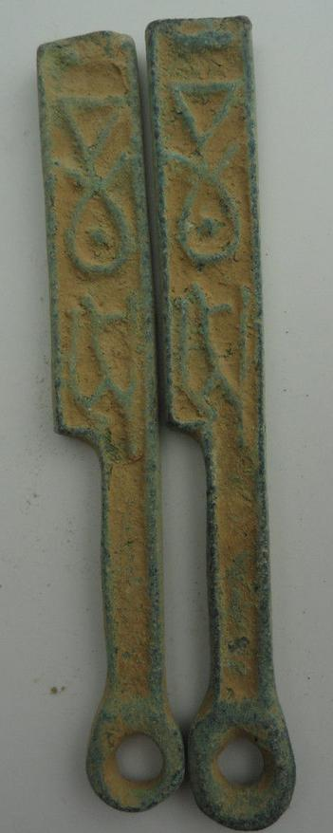

Straight knives 300-250 BCE, Jin Ban (Jin [Yang] half), H 4.72, r 0, DCD 606.

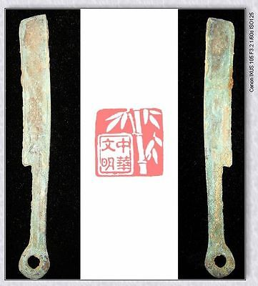

[WarringStatesPeriod ZHAO NATION CAPITAL MINT MONEY BRONZE FALCHION COIN蔺刀4"RARE](http://www.ebay.com/itm/251406281655)

Item price

$9.99

Quantity

1

Item number

251406281655

Shipping service

Economy Shipping from outside US 10.00

[Leave feedback](http://feedback.ebay.com/ws/eBayISAPI.dll?LeaveFeedbackShow&useridfrom=802-867&useridto=bcculture&item=251406281655&transactid=0) [Contact seller](http://contact.ebay.com/ws/eBayISAPI.dll?FindAnswers&frm=3998&iid=251406281655&redirect=0&requested=bcculture) [Return item](http://return.ebay.com/ws/eBayISAPI.dll?ResolveReturn&eventName=viewSelectedItem&TransactionId=0&ItemId=251406281655)